# Energy Budgets: Understanding the heat budget of montane butterflies (Answer Key)

## [Link to the visualization](https://huckley.shinyapps.io/ButterflyAdvanced/)

## [Link to TrEnCh-Ed](https://trench-ed.github.io/#)

## Objectives

* Describe how the properties of organisms influence how they experience their environments.
* Identify the difference between heat and temperature.
* Identify the different heat flows between organisms and their environment.
* Describe how an energy budget is constructed and use it to estimate an organism’s body temperature.
* Explain how organisms use behavior to maintain homeostasis.

## Core concepts -- *BioCore*

* Physiology: Evolution
* Ecology & Evolutionary Biology: Evolution
* Physiology: Information Flow
* Physiology: Structure Function
* Ecology & Evolutionary Biology: Structure Function
* Physiology: Transformations of Energy and Matter
* Physiology: Systems

## Instructions

First, read through the Energy Budgets introduction in the visualization. This will give you the required background information for these exercises.

### Radiation: Reflection and Absorption

1. The paired visual and thermal (dark=cool) images below depict a seastar on a bed of mussels (which are its prey).   
  
 A. How are the temperatures of the   
 seastars and the mussels different?

The seastar’s body temperature is cooler than the mussels.

B. Why do you think they have different body temperatures despite being in the same environment?

The seastar’s light color reflects more solar radiation. The mussels dark color absorbs more solar radiation.

C. How do you think their different temperatures influence the interactions between seastars and mussels?

The seastar might use temperature as a way to identify its prey. The mussels may be able to metabolize at lower external temperatures than the seastar due to their higher internal temperatures.

### Heat and Temperature

1. Given these definitions, consider a pot of boiling water and a large iceberg floating in the ocean. 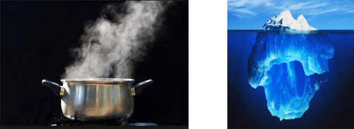

1. Which of these bodies of water contains the most heat? Highlight your selection and explain in part B.

Pot of Boiling Water Large Iceberg

1. Briefly explain your reasoning to your choice above.

An iceberg has much more mass, so it has more heat, but has a lower temperature. The iceberg has more molecules moving than a pot of boiling water, but the pot has a greater temperature and less mass.

2. The distinction between temperature and heat is also central to understanding firewalking-- the act of walking barefoot over a bed on hot embers of stones. Think about the difference between temperature and heat to explain why you think firewalking is possible. (But we’re not recommending you try it out!)

Firewalkers walk briskly over the coals, thereby reducing the time their feet are in contact with the coals. Wood coals used in firewalks are at a high temperature but they are poor thermal conductors and have a low heat capacity. Therefore they do not contain much thermal energy and what heat there is does not conduct very efficiently to your feet.

### Forms of heat flow

1. Do you think losing heat via evaporation is more effective on dry or humid days? Explain your answer. Hint: think about the concept of diffusion.

Losing heat via exportation is more effective on dry days. This is because diffusion works much faster when between more unlike states. Therefore, the drier the day, the more different the saturation of water molecules between the water and the air, and the quicker evaporation takes place.

2. First consider the pictures below (here lighter colors depict warmer temperatures, °F).

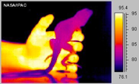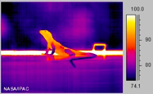

1. What observations do you have about the two images below?

Left image: The lizard is cooler when it is held by the warm hand.

Right image: The lizard is warmer when it is on a cool table .

1. Use the heat flows above to describe how and why the body temperatures of the lizard varies between the two pictures.

In the first image, the lizard is propping itself up and thus allowing for lower heat conduction from the warm hand and more heat convection from the air. In the second picture the lizard is basking, thus increasing its heat radiation from the sun.

3. Next we will consider Emperor penguins and their adaptations to survive the harsh Antarctic climate. For each adaptation below, indicate the heat flow being altered (CONVECTION, CONDUCTION, RADIATION) and provide a brief explanation of how the adaptation works.

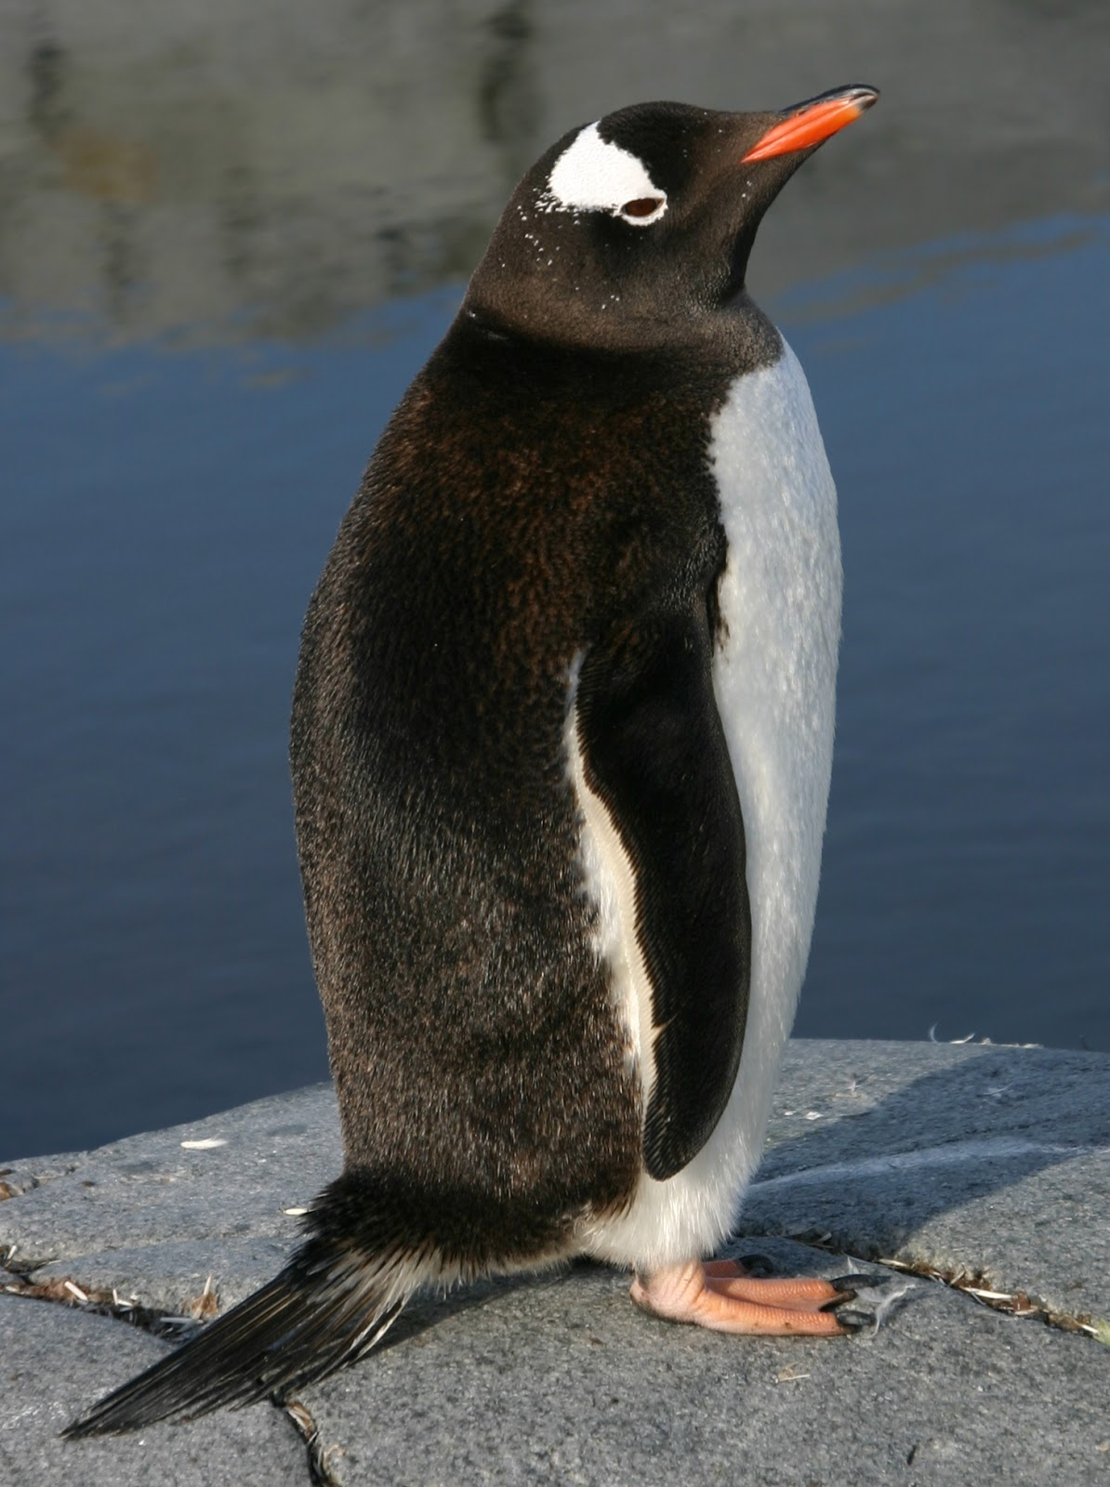

1. Penguins have a relatively large body size.

Heat Flow: Convection

Explanation: Because volume increases more than surface area as an object is expanded, it can retain heat in its larger body and lose relatively less body head due to relatively less surface area.

1. Penguins have a short, stiff tail.

Heat Flow: Convection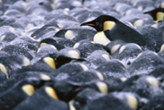

Explanation: A long tail would expose greater surface area to the cooler temperatures. By reducing tail size, penguins reduce heat lost from convection from their tail.

1. Penguins huddle together.

Heat Flow: Conduction

Explanation: Penguins share their body heat with each other by pressing against each other. A student could also argue for convection, in that by pressing their bodies to other penguins, they reduce the percentage of their body exposed to wind.

1. Penguin feet and flippers have a heat-exchange arterial system whereby warm blood leaving the core flows past cold blood returning from the appendages.

Heat Flow: Convection

Explanation: The hot blood heats the colder blood that is returning from appendages, which keeps the blood from freezing.

1. Penguins have dark colored feathers on their back.

Heat Flow: Radiation

Explanation: The lower albedo of the feathers absorb more heat.

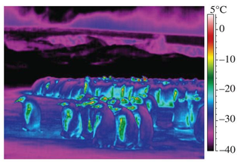

1. Briefly interpret this thermal image of isolated and huddling penguins (*T*air =−21.0°C, from McCafferty et al. 2013. Biology Letters).

The outer bodies of the penguins are colder than the air temperature. Only the flippers and eyes are warmer than the air temperature. This is due to radiative cooling. Due to this, the outer surface will actually **gain** heat by convection from the air.

### Visualization

1. Using the visualization, answer the following questions:

1. How does the estimated butterfly temperature (operative) vary from air temperature (environmental)?

The temperature follows the pattern of the air temperature but is always above the air temperature.

1. At what time of day is the difference between the temperatures the greatest?

This difference is greatest at the hottest temperature of the day.

1. Briefly hypothesize why these differences occur.

This can be due to radiative heating from the sun, warm winds yielding convective heat transfer, or other morphological characteristics of the butterfly.

2. Choose a weather, morphological, and terrain variable to change and describe how the difference between estimated body and air temperature changes. Record observations after each change.

1. Weather

If the weather changes to cloudy, the difference between body and air temperature is much smaller. This is due to radiative heating from the sun being decreased.

1. Morphology

Increasing wing absorbency (albedo), thoracic distance, and fur thickness all yield a greater difference in body and air temperature.

1. Terrain

Increasing ground temperature increases the difference in body and air temperature due to conductive and convective heating. Putting the butterfly in the shade decreases the difference by reducing radiative heating.

3. Return to the variable changes you made in question 2. Now look at the “analysis” section to explore how the variable change influences heat flows. How does the solar radiative heat flux, thermal radiative flux, and convective heat flux change when you change the variable?

|  |  |  |  |
| --- | --- | --- | --- |
| **Variable Change** | **Solar radiative heat flux (mW)** | **Thermal radiative flux (mW)** | **Convective heat flux (mW)** |
| Weather: |  |  |  |
| Morphology: |  |  |  |
| Terrain: |  |  |  |

Briefly explain why you think the heat fluxes are changing.

See above.

### Homeostasis and the influence of behavior

1. Behavior is often an easy way for organisms to adjust their heat exchanges with the environment. Consider the following examples and photos of animal behavior. List and briefly discuss what forms of energy exchange (CONVECTION, CONDUCTION, RADIATION) the behavior is likely to alter.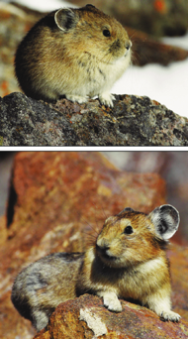

1. An insect “stilts” up on the tip of its legs.

Decreases conduction and increases convection

1. A pika curls up in a ball and minimizes its contact with a rock.

Decreases conduction

1. Alternative, the pika spreads its body out over the rock and spreads its ears.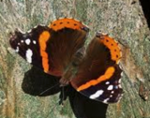

Increases conduction

1. A butterfly orients its dark wings relative to the sun.

Increases radiation

### Synthetic question

1. Consider a squirrel (an endotherm) that is producing heat to maintain a constant body temperature (homeostasis) in a cold environment. How much heat the squirrel produces can be assessed by measuring its metabolic rate.

1. Apply what you’ve learned about energy budgets to draw a line predicting how the squirrel’s metabolic rate will respond to increasing wind speed if it is maintaining homeostasis.
2. Assume that the first line you drew was for a shady environment. Draw a second (dashed) line corresponding to your prediction for a squirrel in a sunny environment.

